**Preston, Margaret (Rose MacPherson, 1875-1963)**

Margaret Preston was a pioneering modernist who worked across a range of media including ceramics, china painting and basketry as well as painting and printmaking. Preston wasattuned to modernism, like many other women artists of her generation. Her reductive portrait, titled *Flapper* (1928), profiles a forceful New Woman or ‘flapper’: a smart, working girl with her own money to spend, the type of girl who entered the factories, commercial and service sectors to fill new jobs in retailing and office work after the War. In both subject matter and pictorial style, Preston aligned herself with the signs of modernity, including urban life and leisure, consumerism and the new production processes. Preston described her kitchen table as a modernist laboratory, and she embraced new technologies, machine-like forms, materials and processes of domestic modernity as fitting subjects for art. We see this in her domestic still life *Implement Blue* (1927), where Preston’s cubist approach to the motif also shows the influence of art deco, cinema and glamour photography. Preston trained initially in Adelaide and at the National Gallery School in Melbourne before heading to Europe in 1904 for the first of many overseas trips. **She m**arried at the close of the War, and remained childless, enjoying financial security and opportunities for international travel that fuelled an ongoing fascination with the art of other cultures.

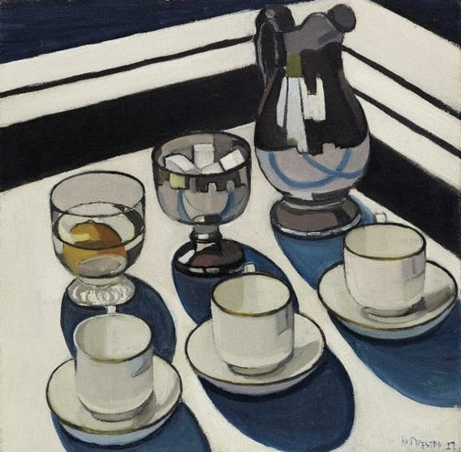

Margaret Preston, *Implement Blue*, 1927, oil on canvas on hardboard, 42.5 x 43.0 cm board; 58.3 x 59.0 x 4.0 cm frame, Art Gallery of New South Wales Gift of the artist 1960

From the mid-1920s Preston argued for a national style based on Aboriginal art. Preston studied and collected Aboriginal art, partly in response to the modern fascination with the arts of so-called ‘primitive’ peoples. Yet unlike the masculinist, avant-garde primitivism of Picasso or Gauguin, Preston’s appropriation of Aboriginal art is bourgeois, feminine and domestic, as in her reductive, cubist-inspired oil painting of a bouquet of parrot feathers purchased by the artist from a souvenir stall in Far North Queensland, titled Aboriginal Flowers (1928), or her 1936 hooked rug, patterned with a decorative twirl of hakea flowers, in the style of the British Omega Workshop. While her formalist appropriation of Aboriginal art and design would be deemed racist by today’s standards, her claims for the international significance of Aboriginal art, and for its appropriation in modern Australian art and design were undeniably progressive in the context of contemporary protectionist and assimilation policies towards Australia’s indigenous communities.

**References and Further Reading:**Edwards, D. and Peel, R. (2005) *Margaret Preston*, Sydney: Art gallery of New South Wales (This scholarly exhibition catalogue, with time-line and CD-ROM catalogue raisonné of paintings, monotypes and ceramics, is comprehensive and informative).

Butler, R. (2005) *The prints of Margaret Preston*, Canberra: National Gallery of Australia (A well-illustrated listing of Preston’s prints, with bibliographical information and discussion of her print-making techniques).

Smith, T. (2002) *Transformations in Australian Art: The Twentieth Century – Modernity and Aboriginality*, Sydney: Craftsman House (A discussion of Preston’s relation to both metropolitan modernism and Indigenous art).

Kerr, J and Stephen, A. ‘Margaret Preston’, *Design and Art of Australia Online,* 1995, ([www.daao.org.au/bio/margaret-preston/biography/?)é](http://www.daao.org.au/bio/margaret-preston/biography/?)é) (Useful further bibliographical information on Preston).